DOCKER – TASK – 01
==================================================================================

- Setup a virtual machine using Ubuntu image.

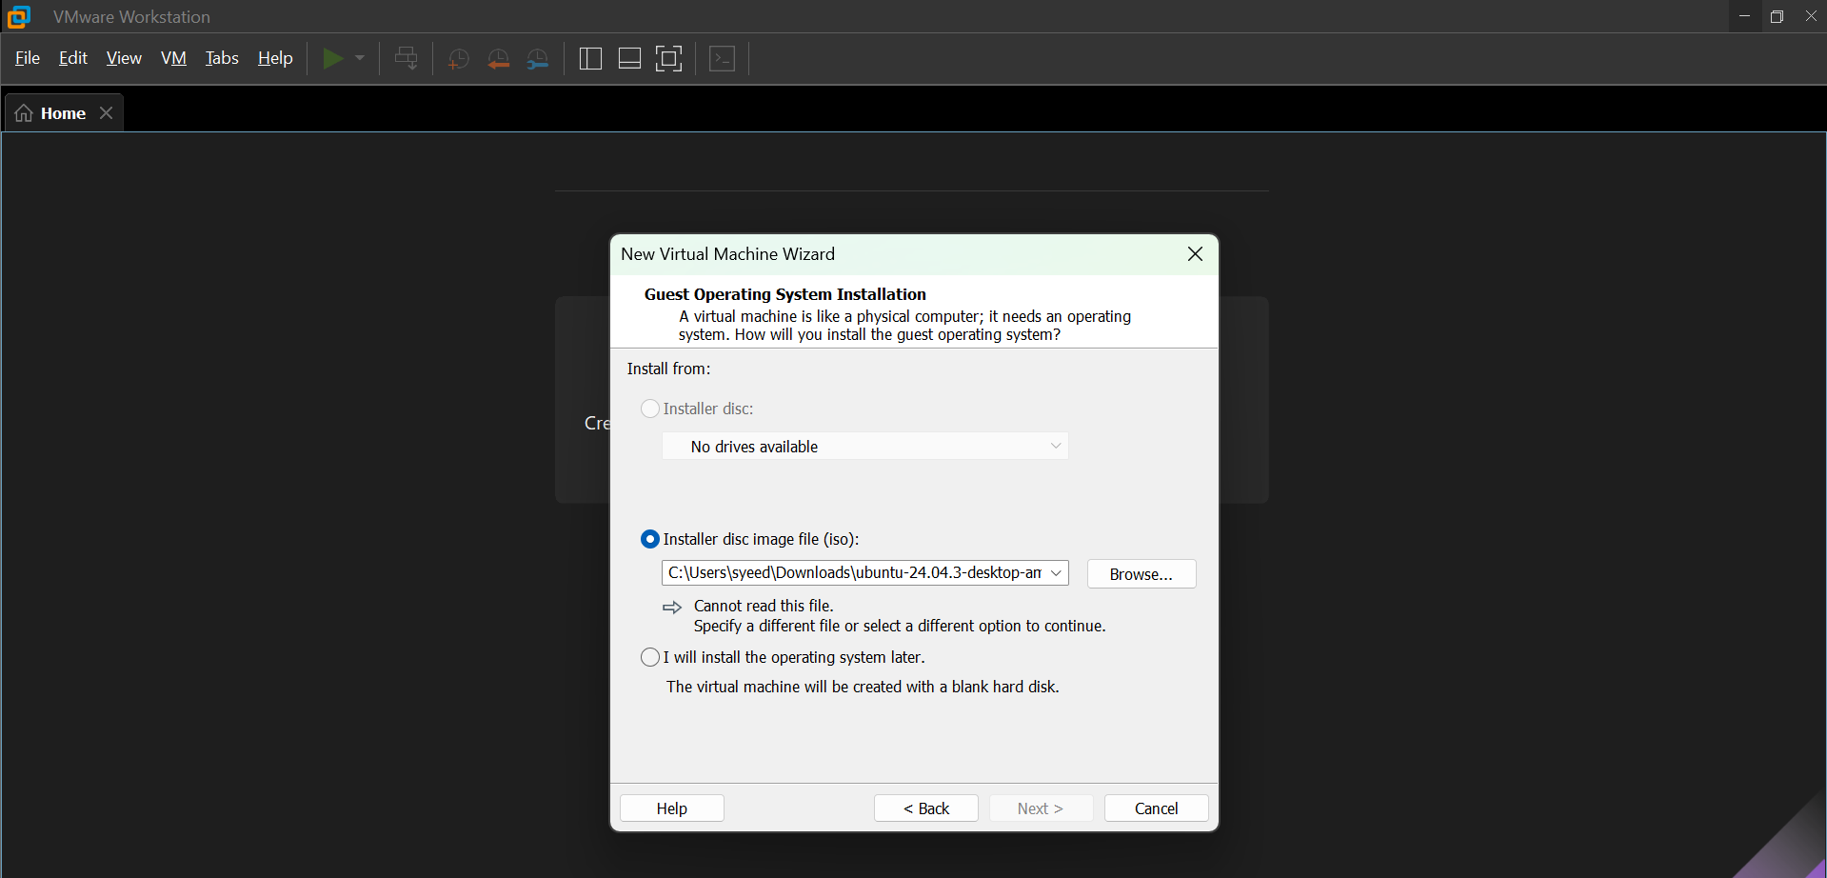

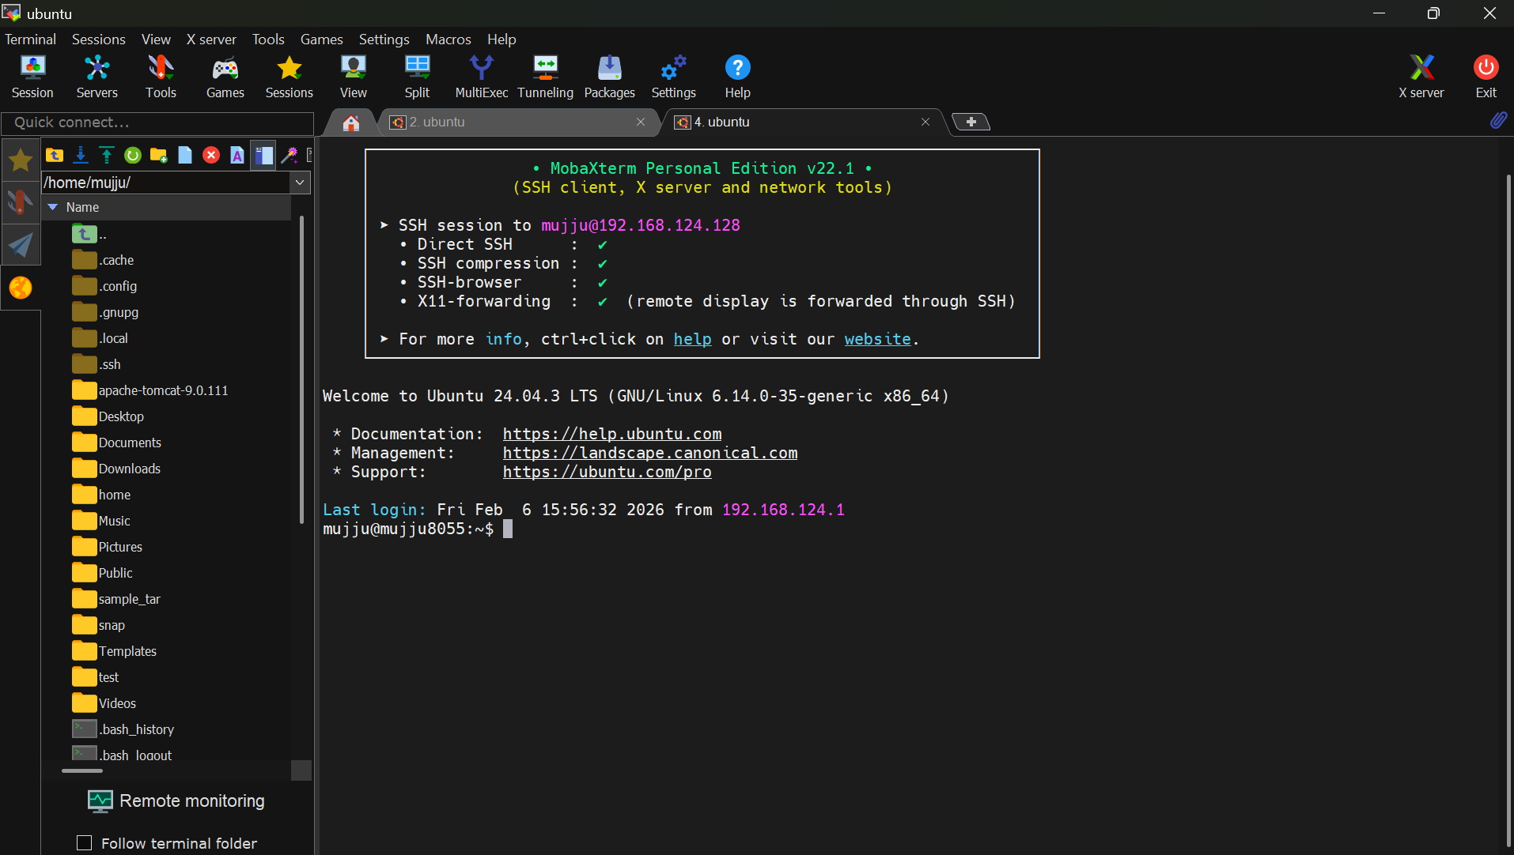

- Install docker on ec2.

AWS Console → EC2 → Launch Instance type-large
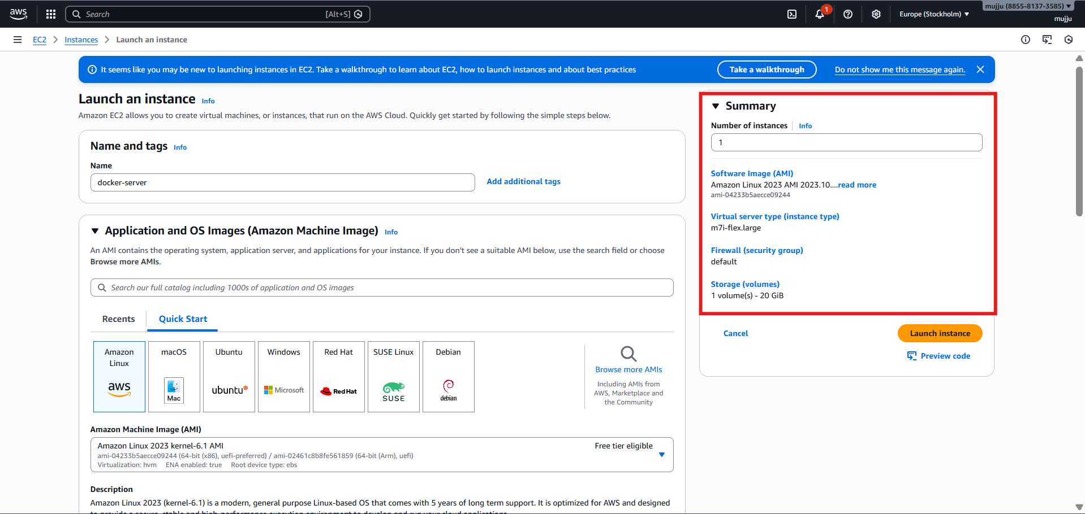
Installed docker using
yum install docker -y command
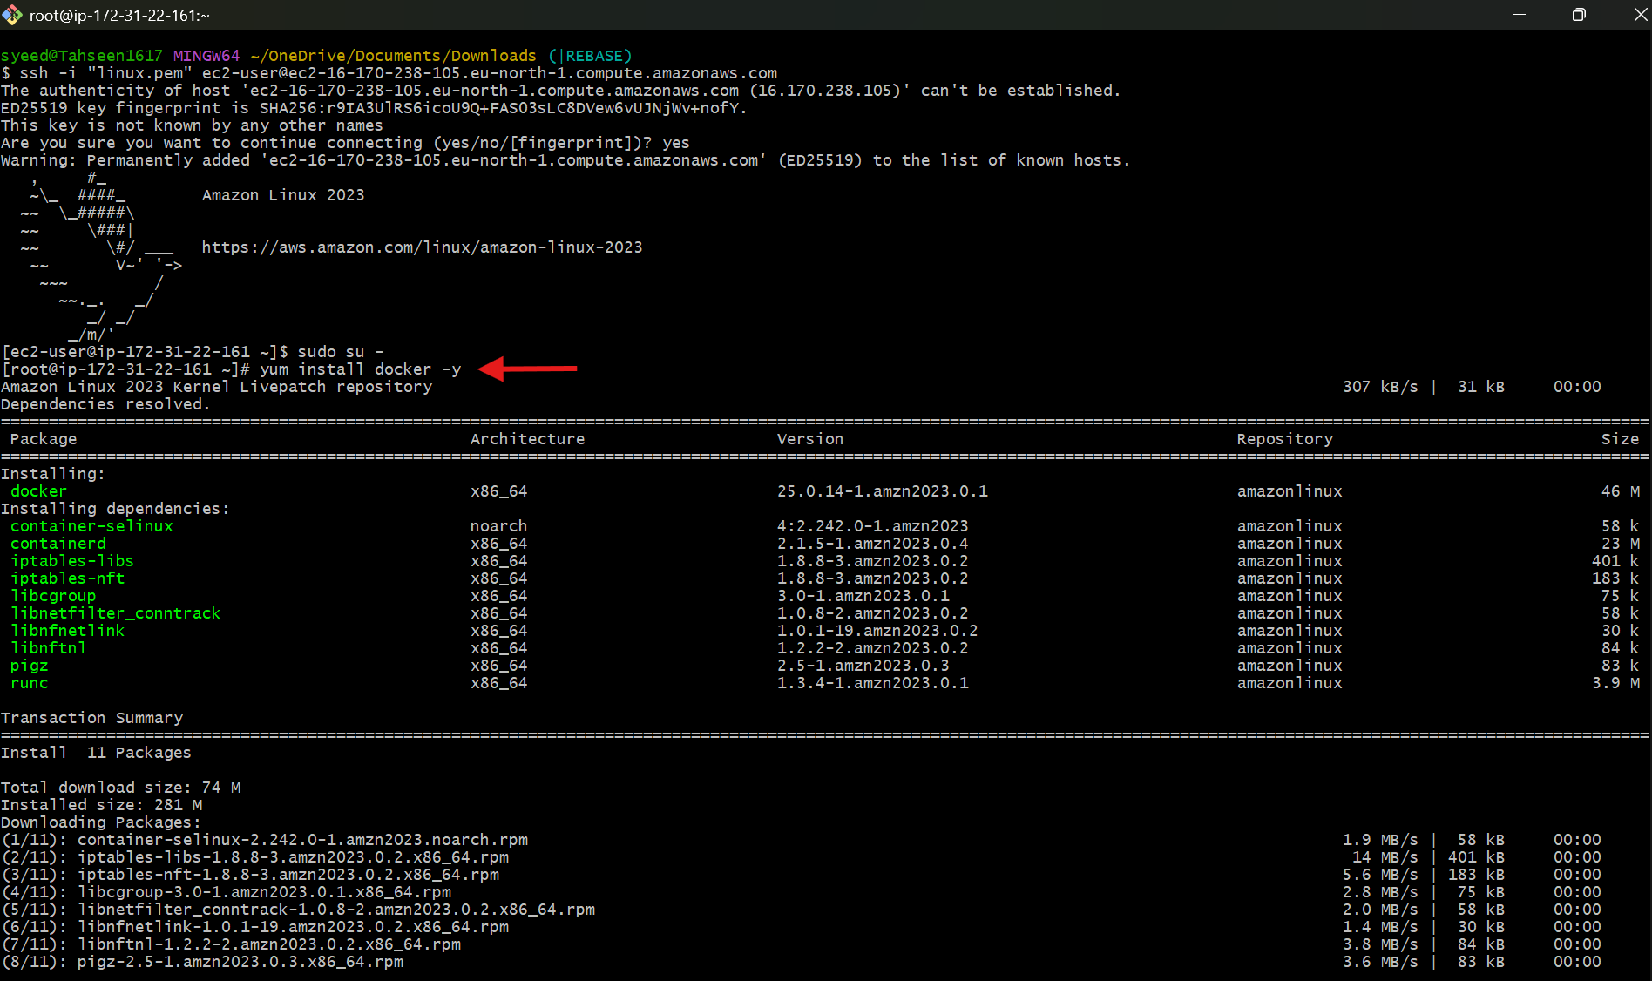

Started docker and checked status by using systemctl commands
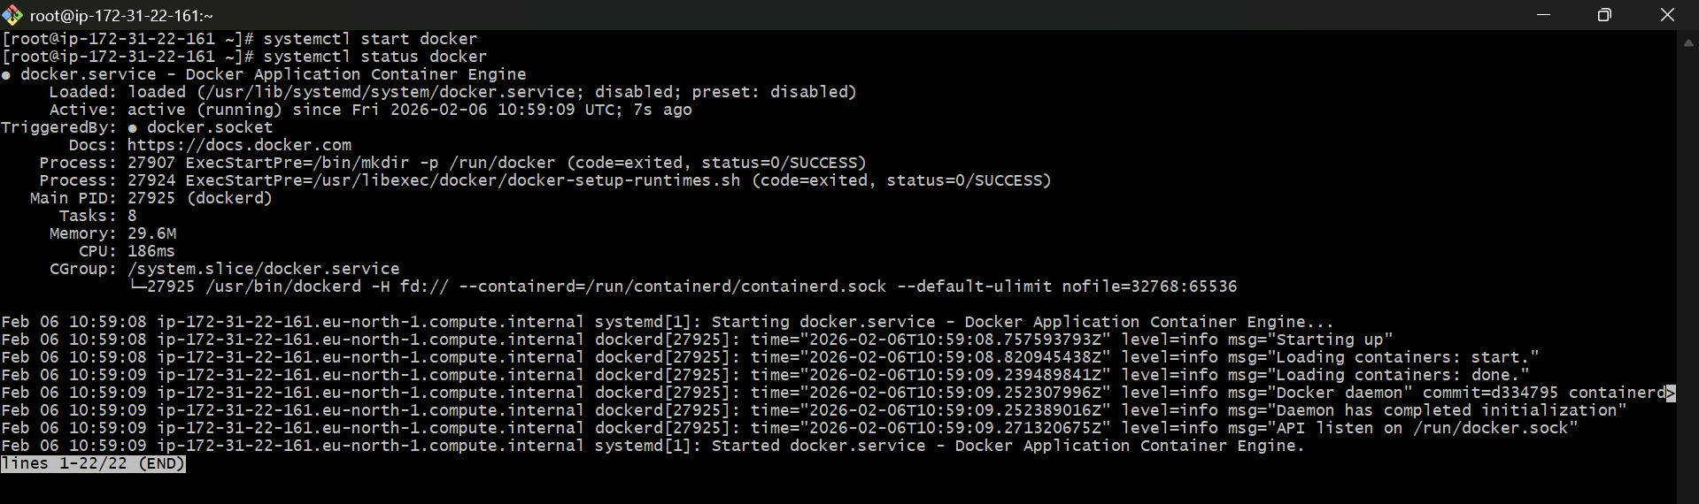

- Pull 5 docker images.(nginx,apache tomcat,ubuntu,jenkins,sonarqube)
Pulled nginx by using : docker pull nginx command
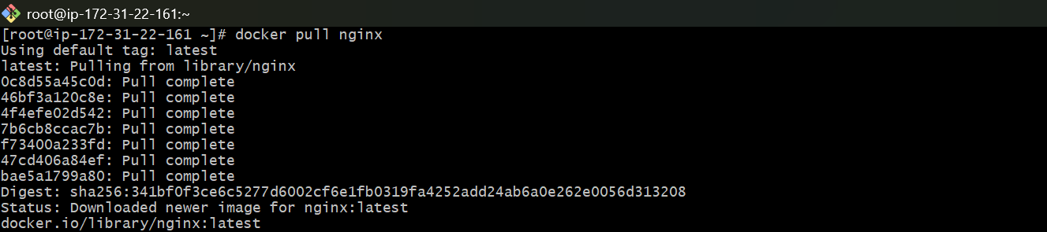

docker pull tomcat
docker pull ubuntu
docker pull jenkins/jenkins
docker pull sonarqube

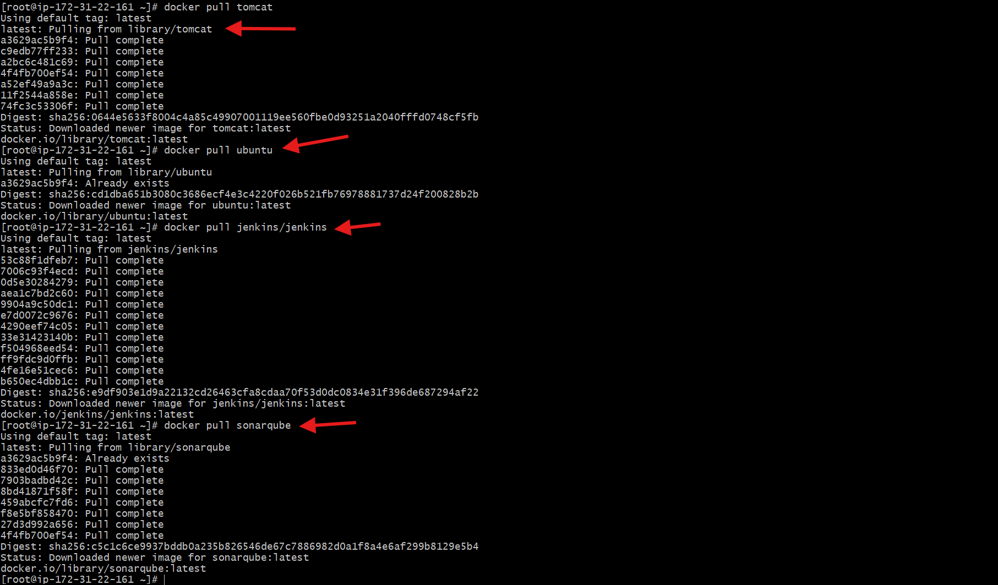
and verified them by using “docker images” command

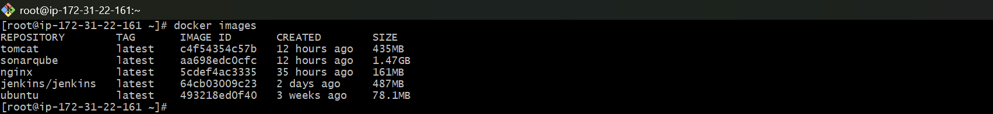

- Run nginx container and expose on port 81.

“docker run -d -p 81:80 nginx” used this command to change port number of nginx from 80 to 81
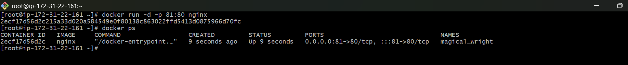
Verified it on browser by using the public and changed port
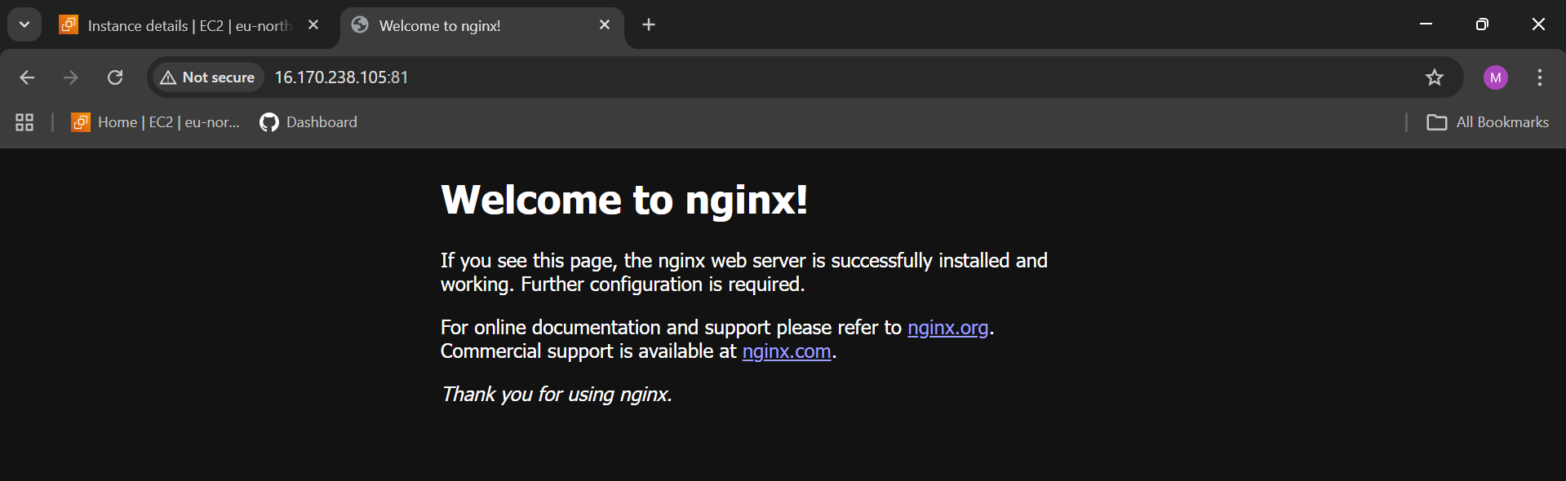

- Delete the apache tomcat image from local.
Checked the pulled images by using “docker images command”
Deleted tomcat image by using “docker rmi tomcat command”
Verified it
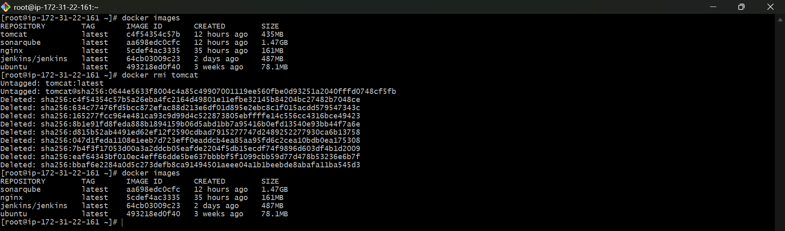

- Inspect the jenkins image,sonarqube image.
To get the full details of an image use inspect command here for Jenkins I have used “docker inspect jenkins/jenkins” command
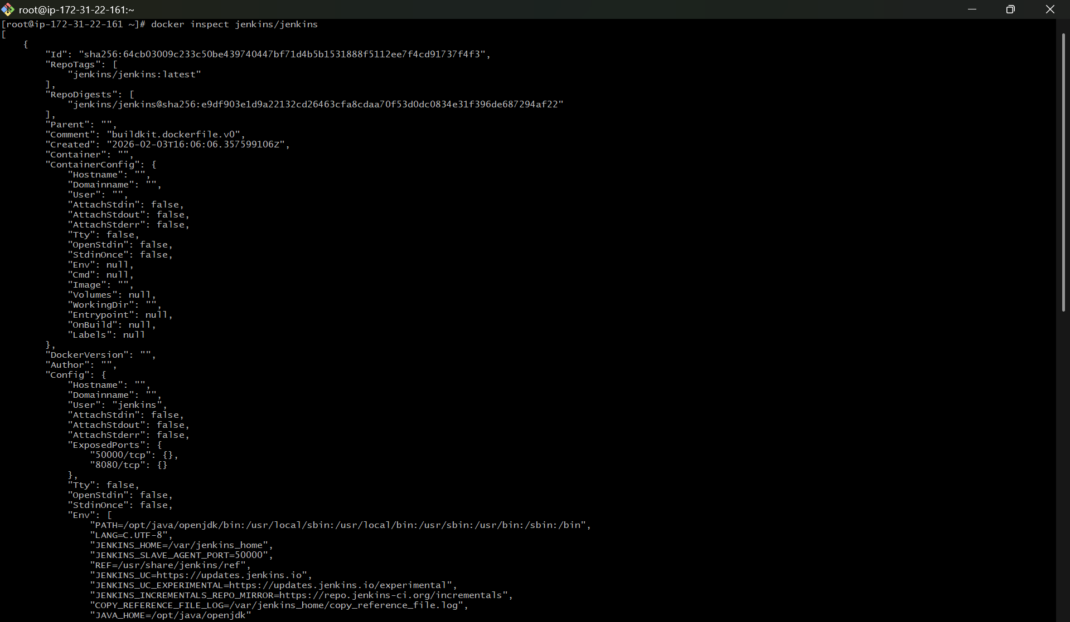

For sonarqube used “docker inspect sonarqube” command
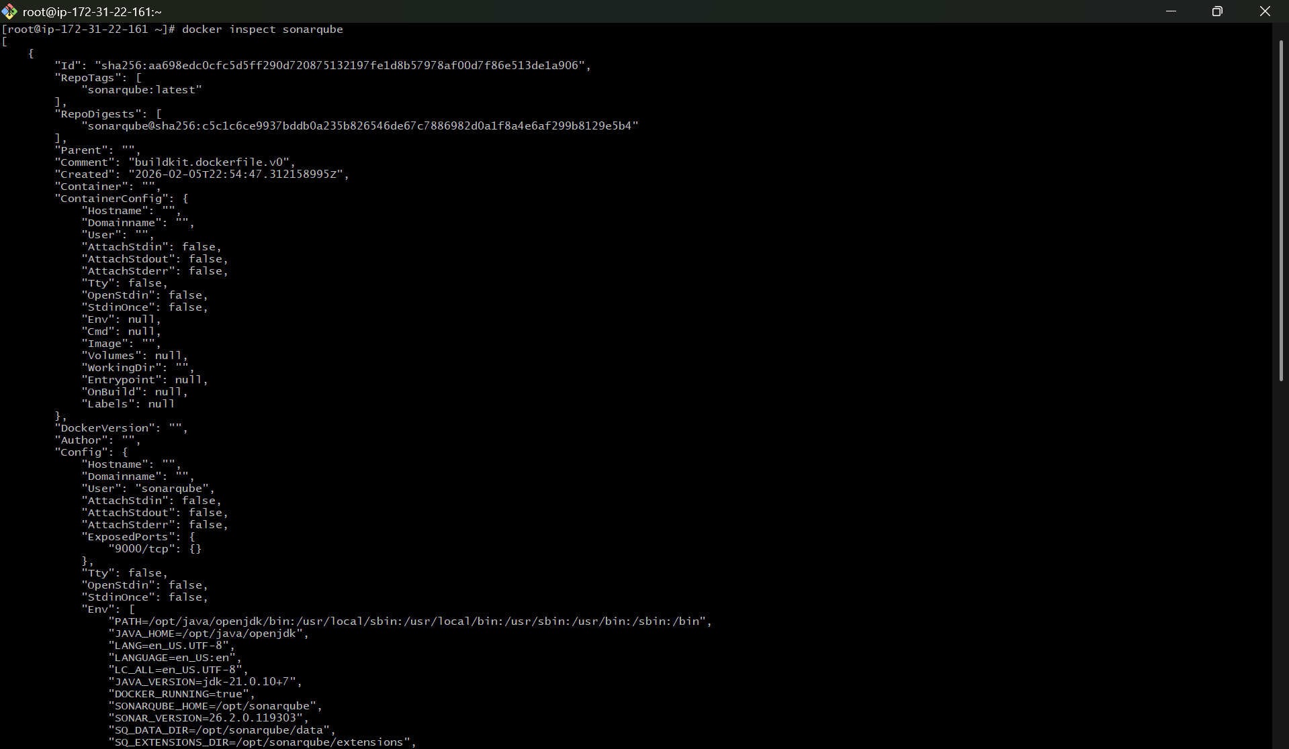
7) Run jenkins contianer and run one sample job.
docker run -d -p 8000:8000 -p 50000:50000 jenkins/Jenkins
docker run | Create and start a container
-d | Run in background (detached mode)
-p 8000:8000 | Map port 8000 (host) → 8000 (container) (Jenkins Web UI)
-p 50000:50000 | Map port 50000 → 50000 (Jenkins agents)
jenkins/jenkins | Official Jenkins Docker image

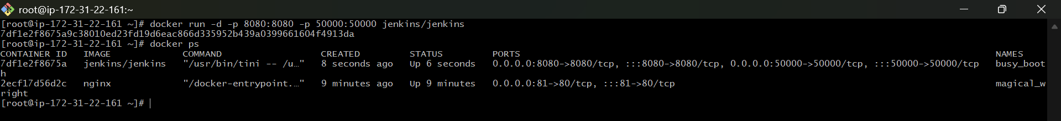

Took the public ip and 8080 port and accesed it on browser opened Jenkins console page
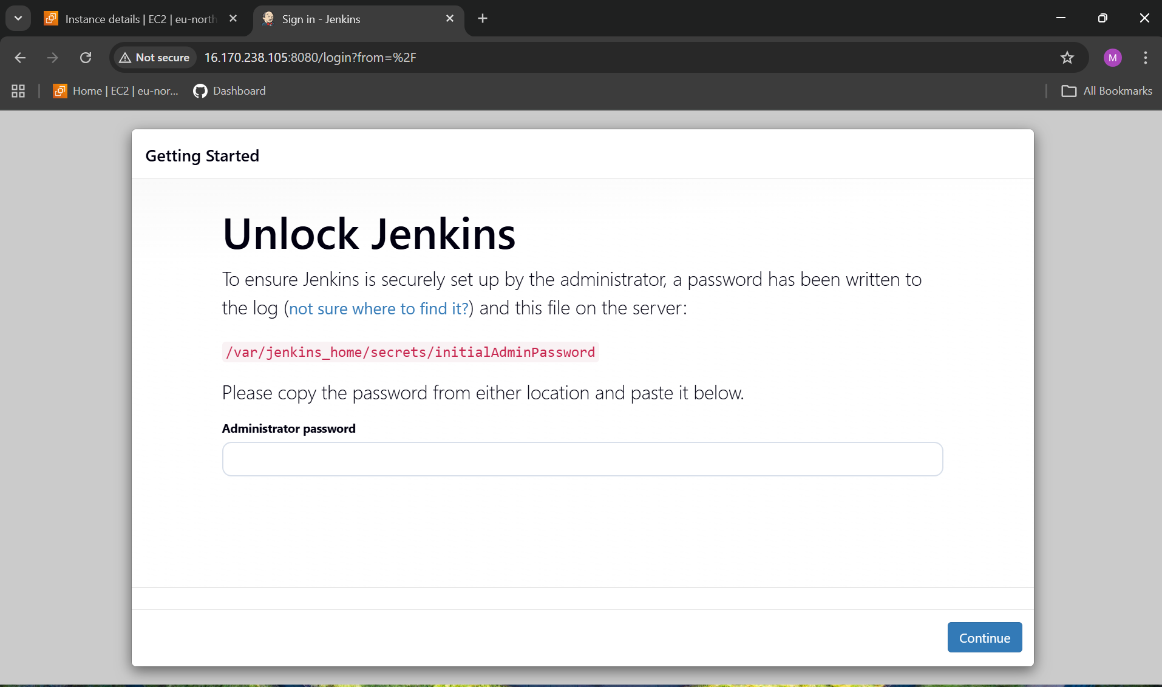
docker exec -it busy_booth cat /var/jenkins_home/secrets/initialAdminPassword
Part | Meaning
docker exec | Run a command inside a running container
-it | Interactive terminal
busy_booth | Container name (your Jenkins container)
cat | Display file content
/var/jenkins_home/secrets/initialAdminPassword | Jenkins password file

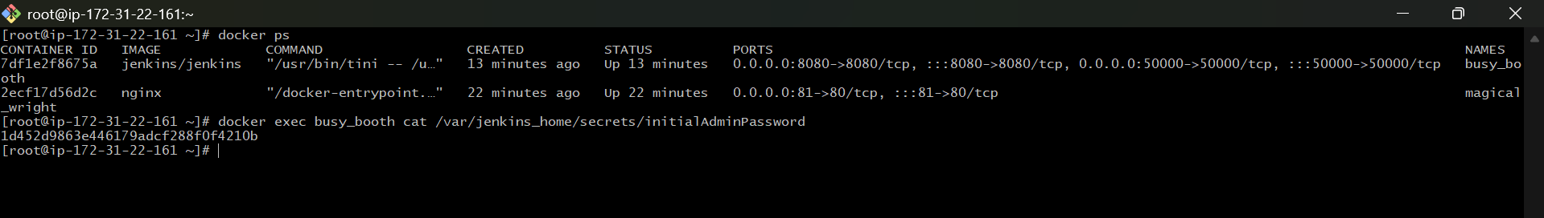

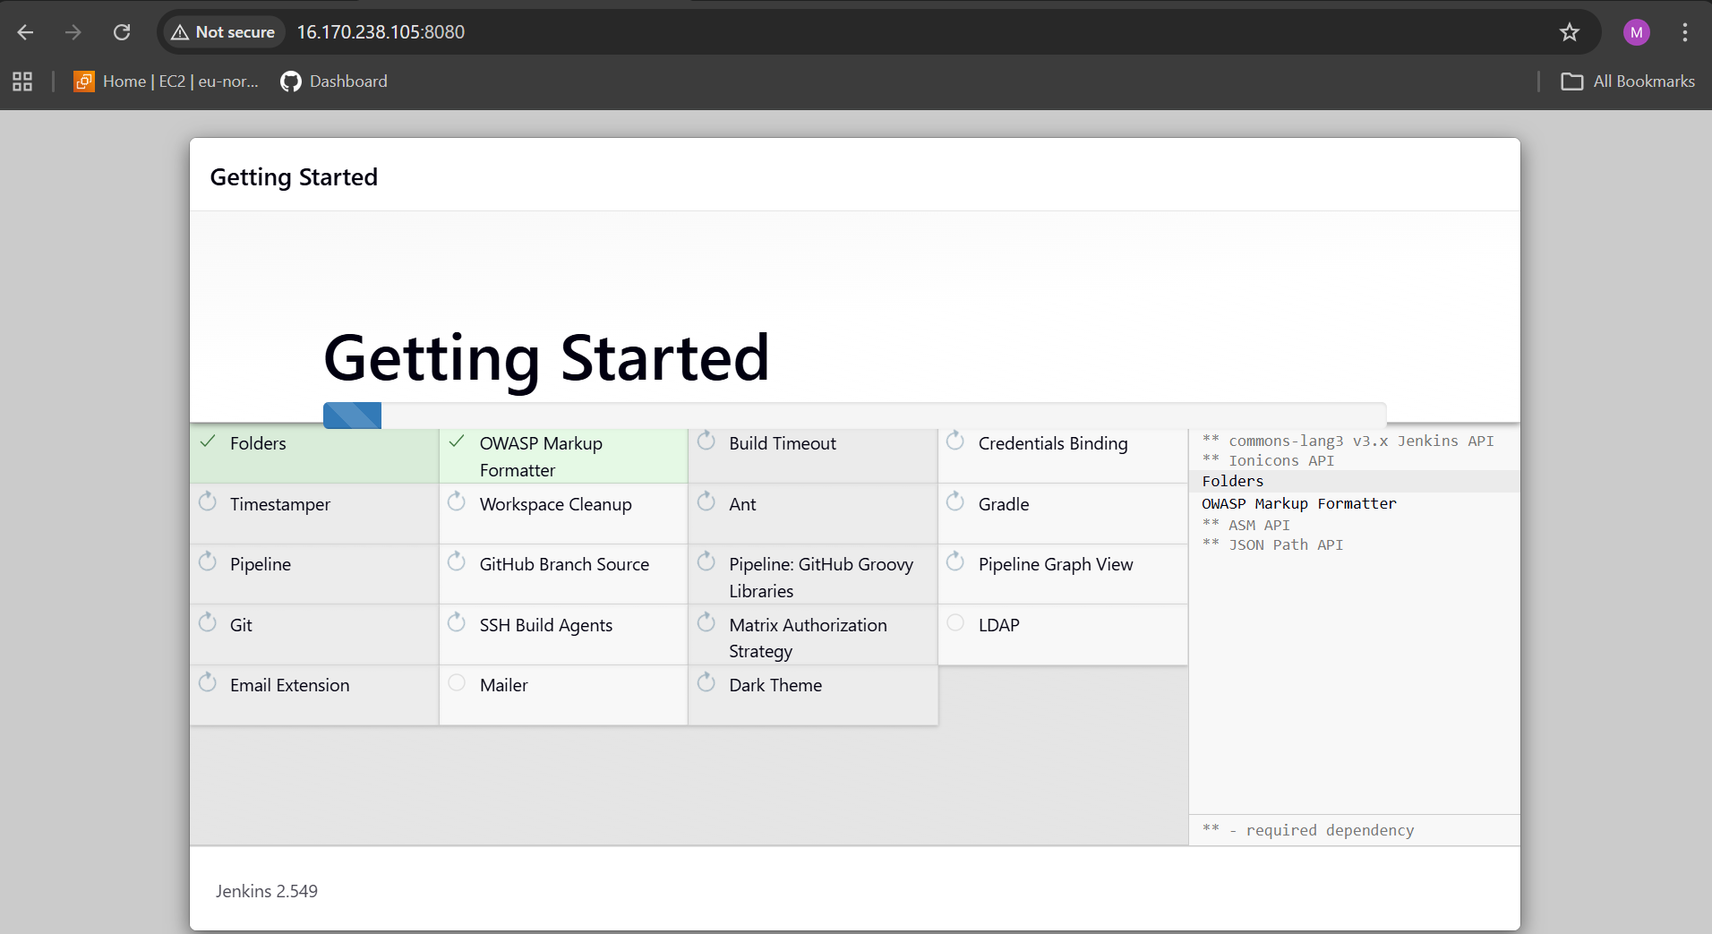
Created a new pipwline job named docker-sample
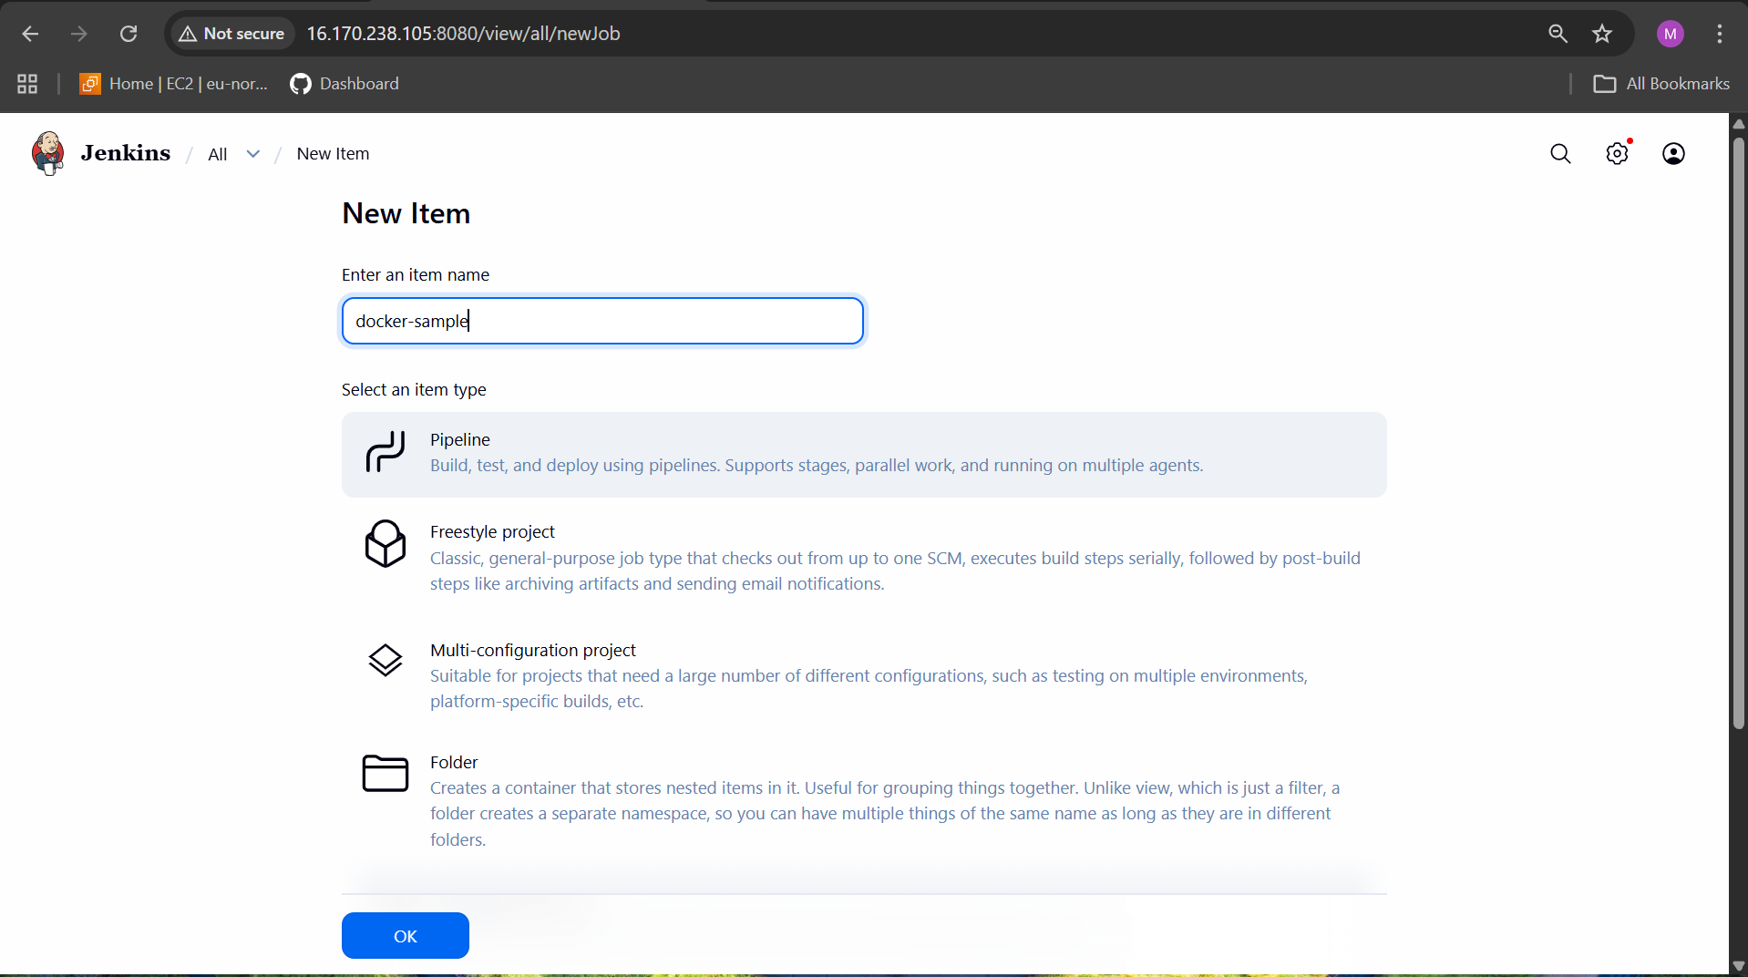
Used a sample pipeline and in job configuration
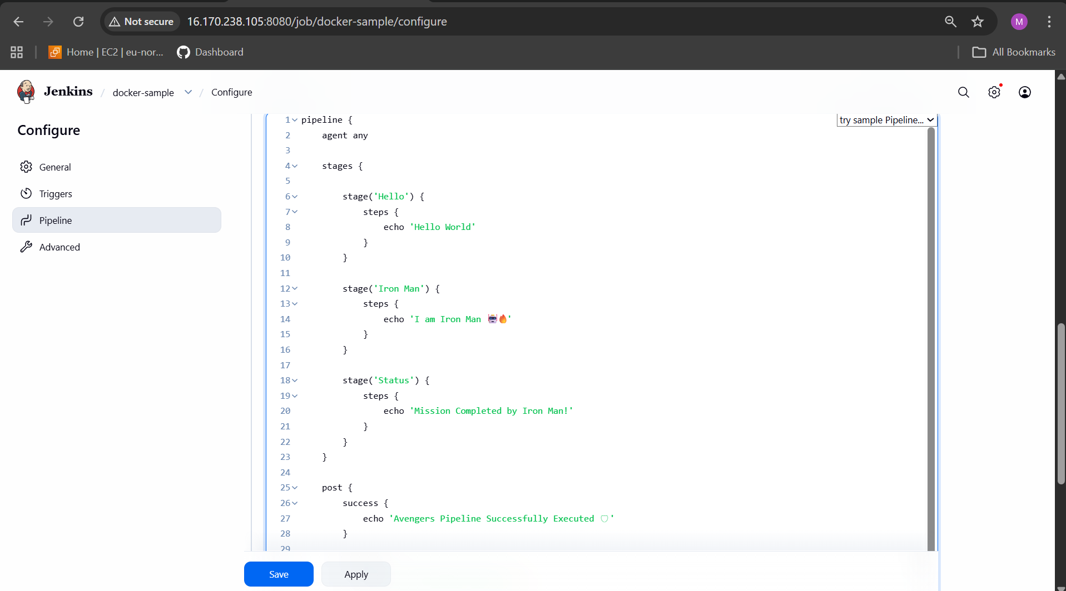
The build was success and it was shown in stage view
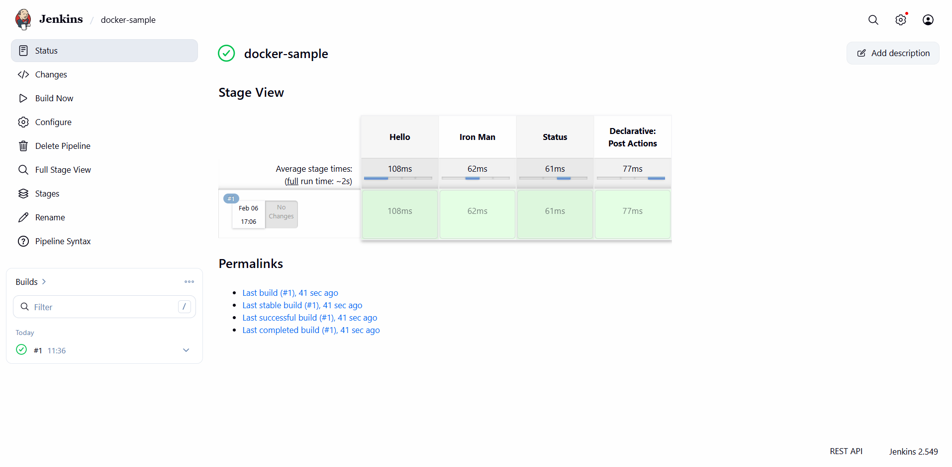

This was the console output
